$I->seeResponseCodeIs(200); $I->seeResponseIsJson(); $I->seeResponseContainsJson([

'title' => 'New Title',

'text' => 'Old Text For Updating',

]);

}

public function testDelete(ApiTester $I)

{

$I->sendDELETE('/api/posts/3'); $I->seeResponseCodeIs(204);

}

}

8. Run application server:

tests/bin yii serve

9. Run API tests:

composer exec codecept run api

Now see the result:

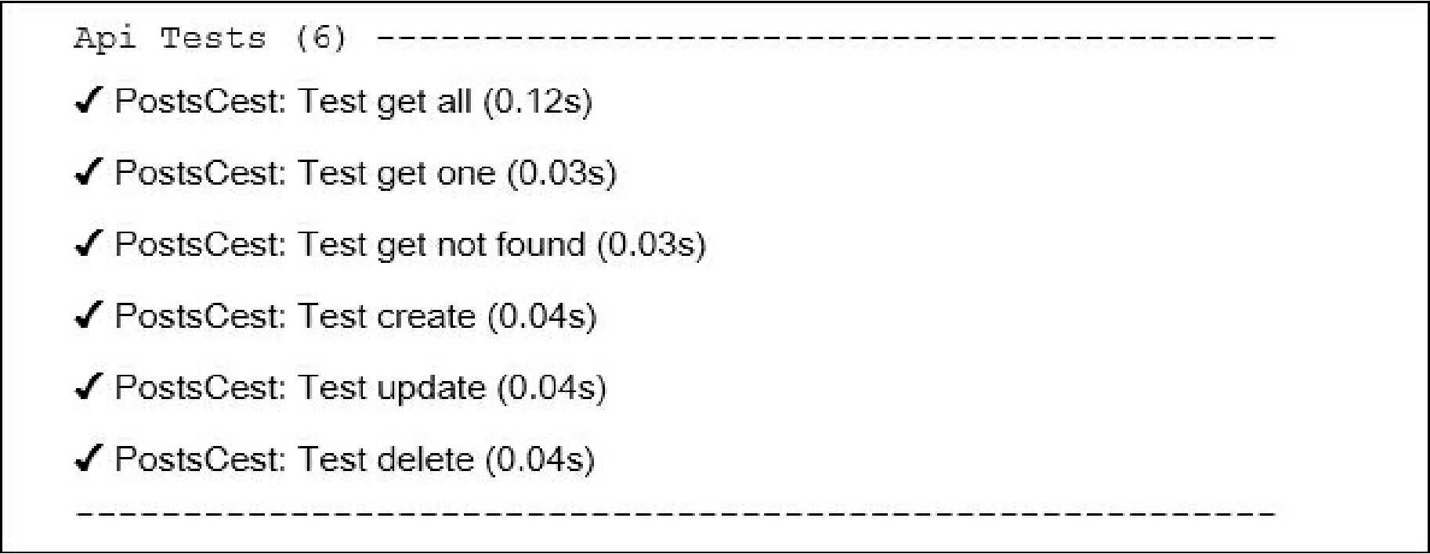

All tests passed and our API works correctly.

How it works...

Codeception is high-level testing framework, based on the PHPUnit package for providing infrastructure for writing unit, integration, functional, and acceptance tests.

We can use built-in Yii2 module of Codeception which allows us to load fixtures, work with models and other things from Yii Framework.